Video 1 : Introduction to OS

Batch Process : Process executed in sequence

Multiprogramming : better CPU utilization(excutes if I/O not required)

Multitasking : multiplexing among jobs like round-robin algo I say

Multiprocessing : lot of cpus working independently

Realtime : Hard/soft/firm

Video 2 : Process, PCB and attributes

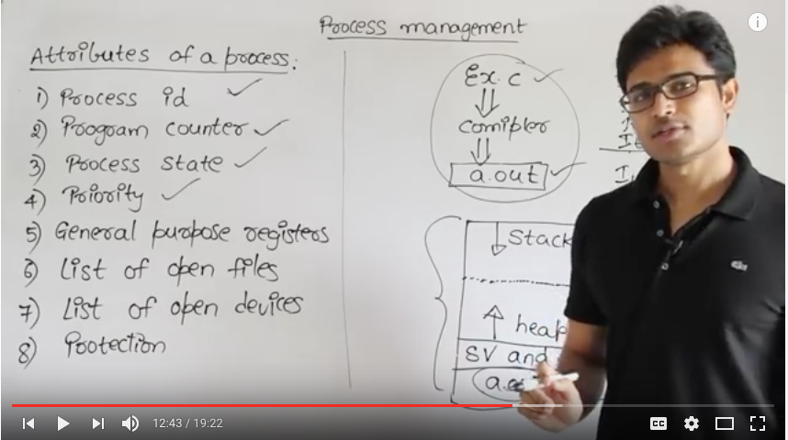

Video 3 : Process States and Multiprogramming

New, Ready, Run, Block or wait, Terminaion or Completion, Suspend/Ready, Suspend/block or Suspend/wait

Creation, Scheduling, Execution, Killing/Delete

Video 4 : Process State Transition Diagram and various Schedulers

Long term schedulers : how many processes should be? (new -> ready)

Medium term schedulers : suspension decisions ( medium time req )

Short term scheduler : which process should run? (ready -> run)

Video 5 : Question on Process States ---

Video 6 : Various times related to process

Arrival time : time at which process enters ready queue

Burst time : time reqd by process to finish (cpu time)

Completion time : time at which process leaves/finishes

Turn around time : ( completion time – arrival time ) = (waiting time + burst time)

Waiting time : time at which process is waiting/suspended

Response time : first time process hits the CPU

Video 7 : CPU Scheduling ---

Video 8 : FCFS(First Come First Serve)

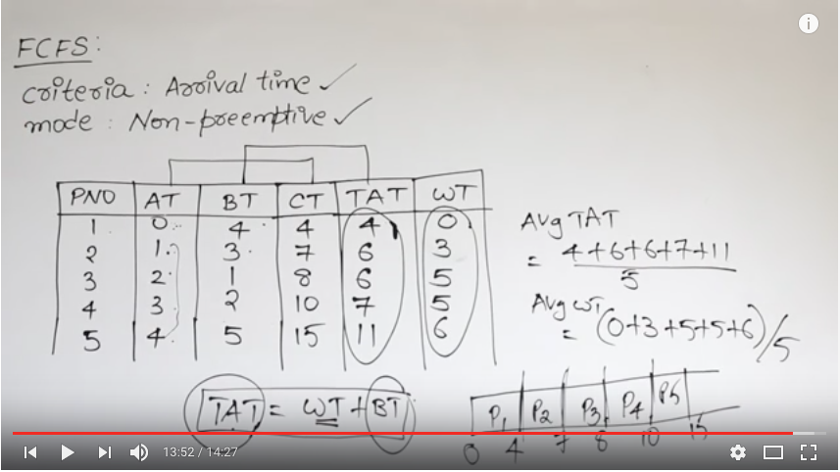

Video 9 : Convoy effect

In FCFS, if longer burst time process gets scheduled first, causes rest to starve.

Video 10 : FCFS Example ---

Video 11 : FCFS with overhead ---

Video 12 : SJF ---

Video 13 : Analysis of SJF

Chance of convoy effect is there.

Video 14 : Round Robin Algorithm ---

Video 15 : SJF with prediction of BT

Maximum throughput

Minimum waiting time/turnaround time

Probable chances of convoy effect(starvation)

With BT unimplmentable as BT can’t be predicted in advance

Video 16 : RR Example 1

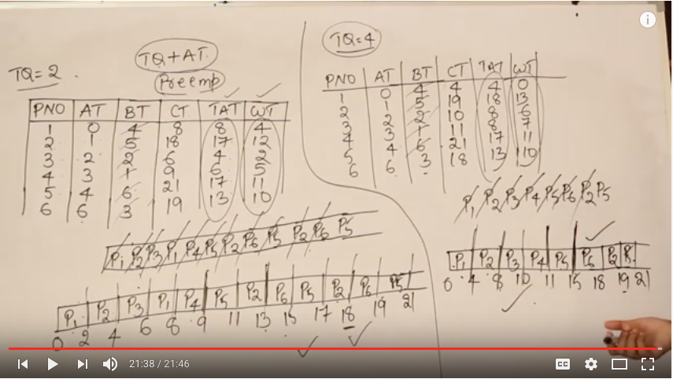Video 17 : RR Example 2

Time Quantum increases, then Context switching decreases, response time increases

Video 18 : Round Robin Example 3 ---

Video 19 : Round Robin Example 4 ---

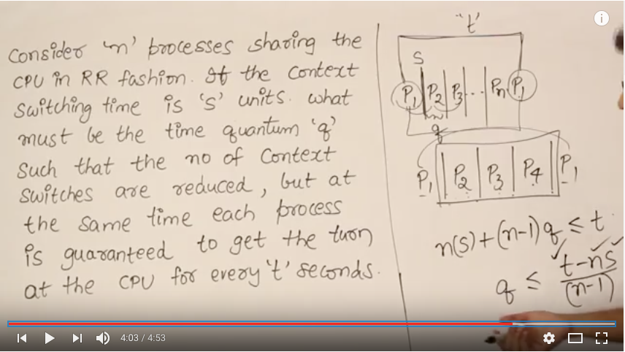

Video 20 : Longest Job First ---

Video 21 : Longest remaining time first

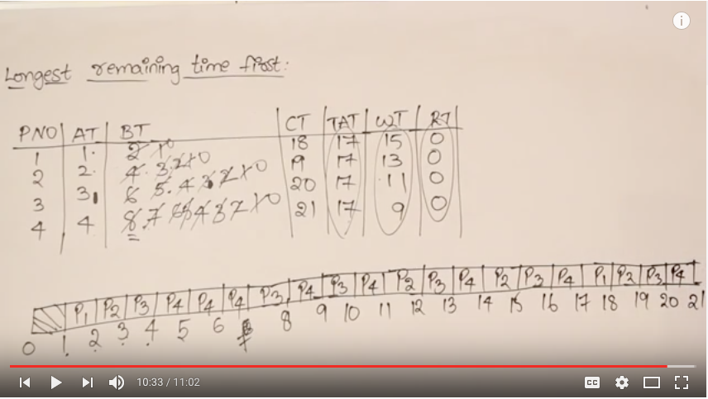

Video 22 : Longest remaining time first gate 2006 question ---

Video 23 : Highest Response Ratio Next(HRRN)

Response Ration(RR) : (Waiting time + Service time) / Service time

Favours shorter jobs, but limits waiting time for longer jobs

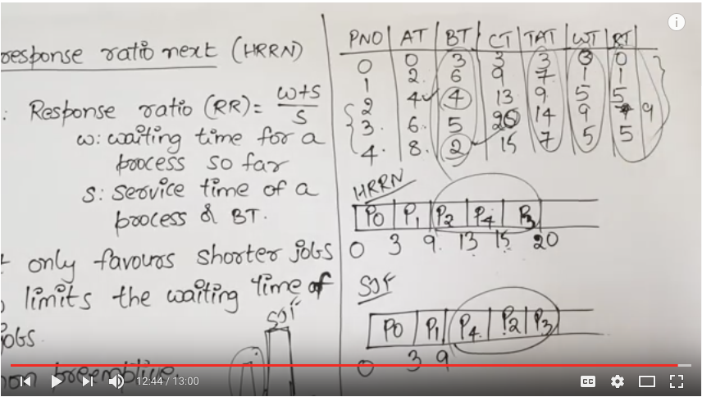

Video 24 : Priority Scheduling

Static(priority doen’t changes in runtime) and Dynamic(not in scope)

Preemptive and Non-Preemptive Scheduling

Video 25 : Non-Preemptive priority scheduling

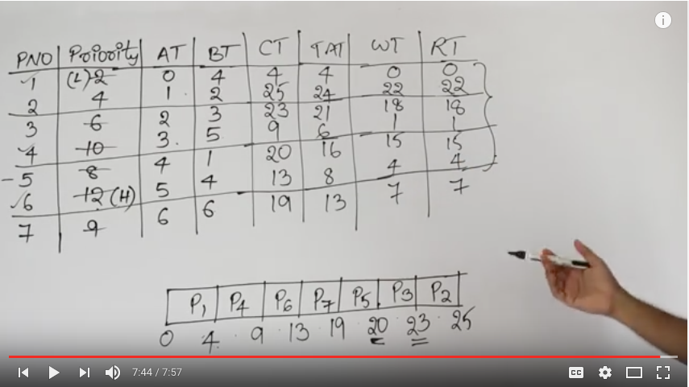

Video 26 : Pre-emptive priority scheduling

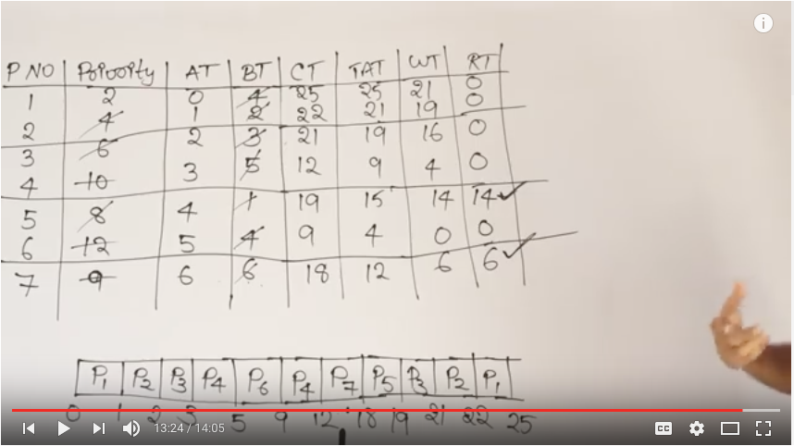

Video 27 : Preemptive Priority with processes contains CPU and IO

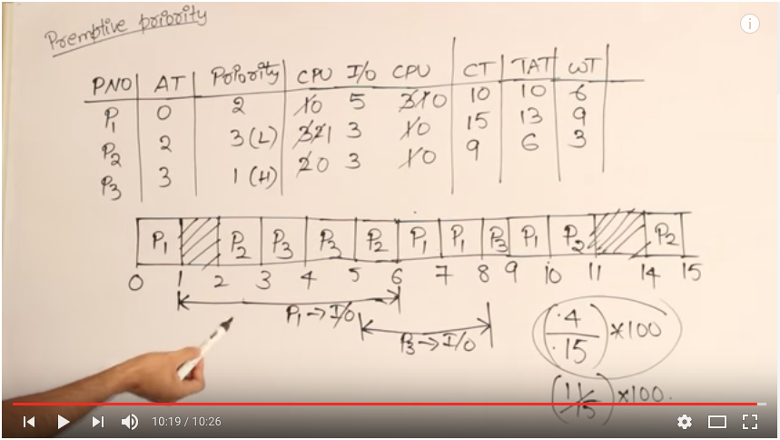

Video 28 : SRTF with processes containing CPU and IO Example 1

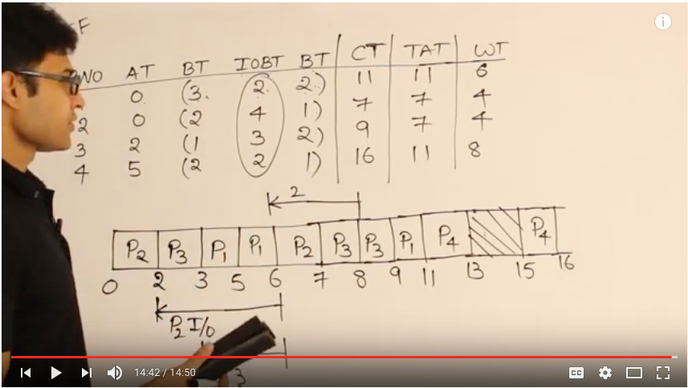

Video 29 : Multilevel Queues and multilevel feedback queues

System Process - Highest Priority - FCFS

Interactive Processes - Medium Priority - SJF

…………………….. - …………………….. - RR

Student Process - Low Priority - LJF

Video 30-33 : SRTF Examples and Analysis ---

Video 1 : Race Condition | Process Synchronization | Process Management

Context switch can be done between any two process between any 2 instructions

Area where shared resources are accessed is called critical section

Only one process can enter shared resource at a time.

Video 2 : Race Condition | Example Problem

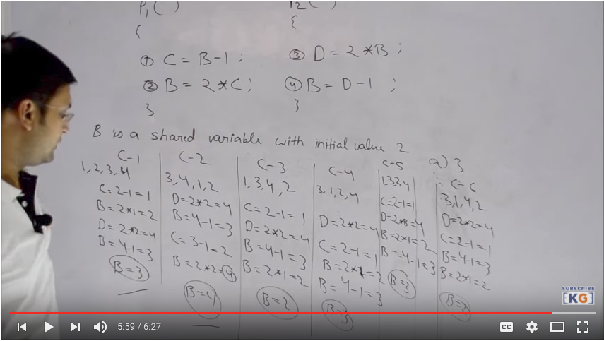

Same code giving diff results is called race condition

Video 3 : Critical Section Problem

Three criterions :

1] Mutual Exclusion

2] Progress (No cycle/round-robin type algo)

only those process should be in line who want to go in critical section

3] Bounded Wait (optional)

Video 4 : Two Process Solutions Case 1 Critical Section Problem

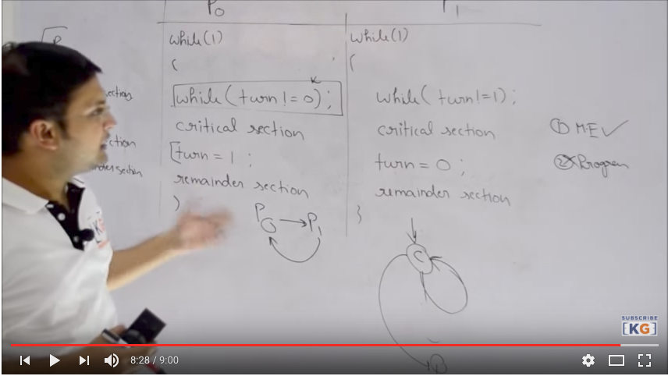

Video 5 : Two Process Solutions Case 2 Critical Section Problem

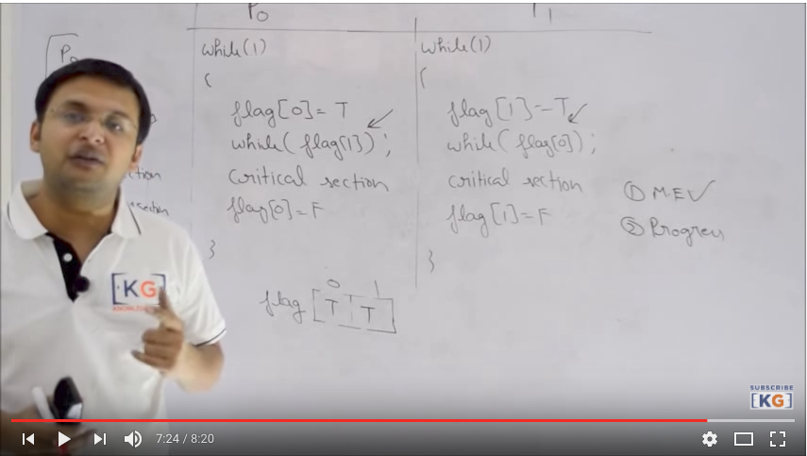

Video 6 : Peterson’s solution Case 3 Critical Section Problem

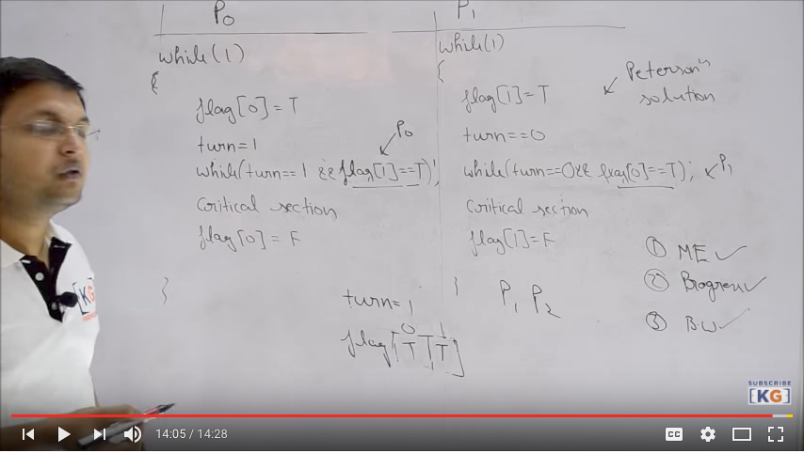

Video 7 : Previous Year Gate Questions | Process Synchronization

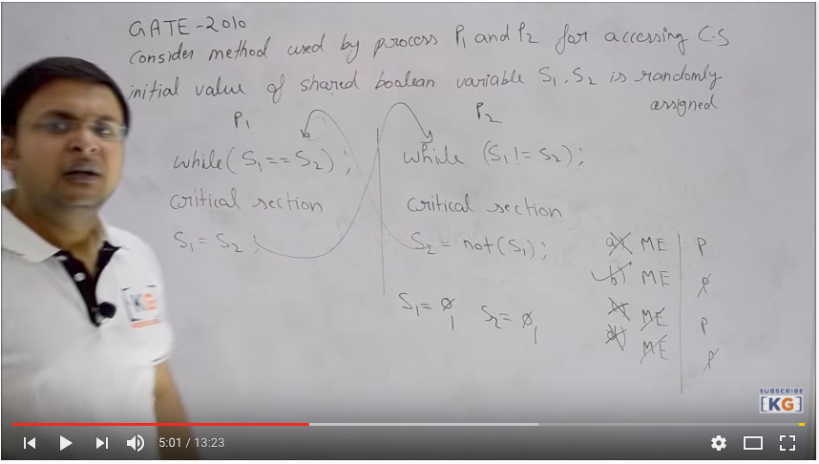

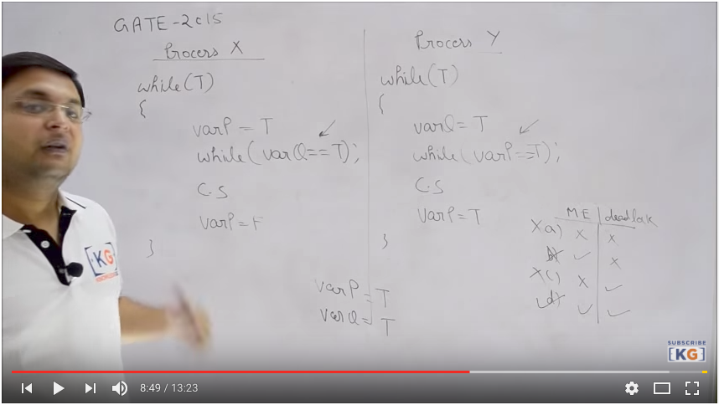

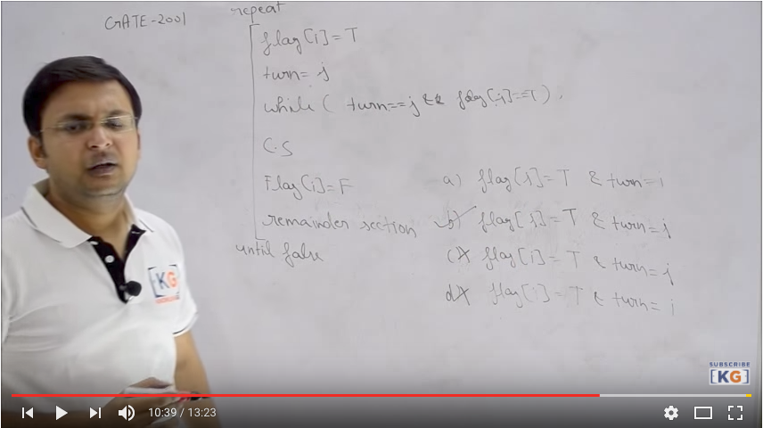

Video 8 : Semaphores | Process Synchronization

Integer variables accessed only by std. atomic operations despite initialization

Semaphore can handle– critical section problem, order of execution, resource mgmt.

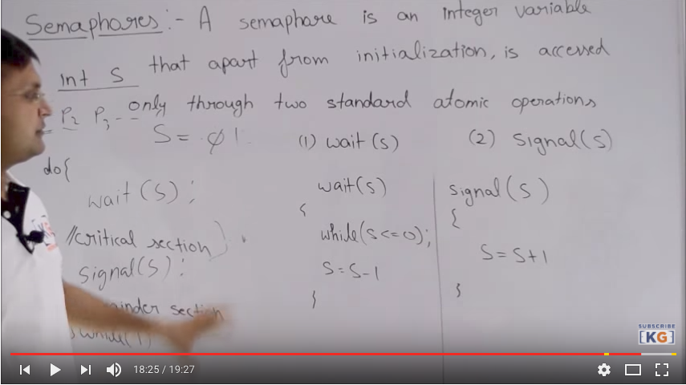

Video 9 : Practice Problem | Synchronization

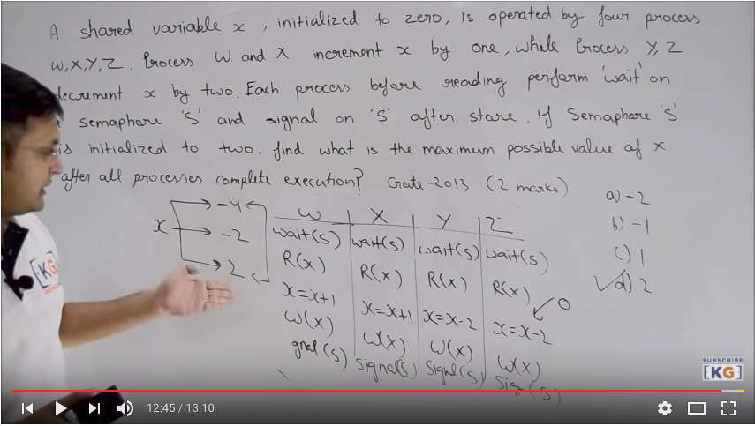Video 10 : Semaphores | Continues | Process Synchronization

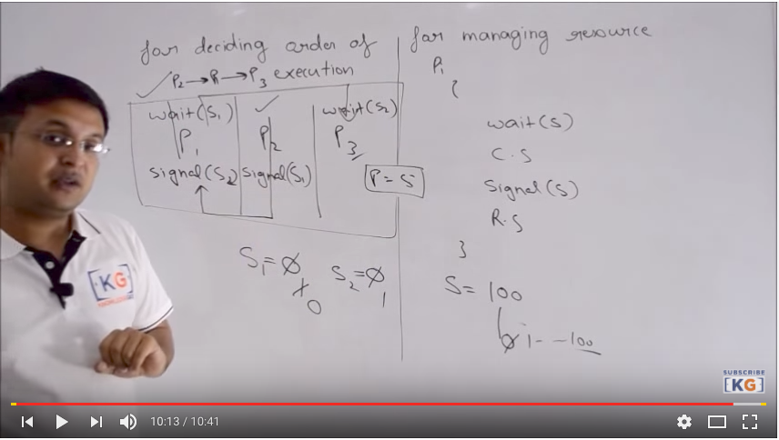

Video 11 : Previous Year Gate Questions | Semaphores

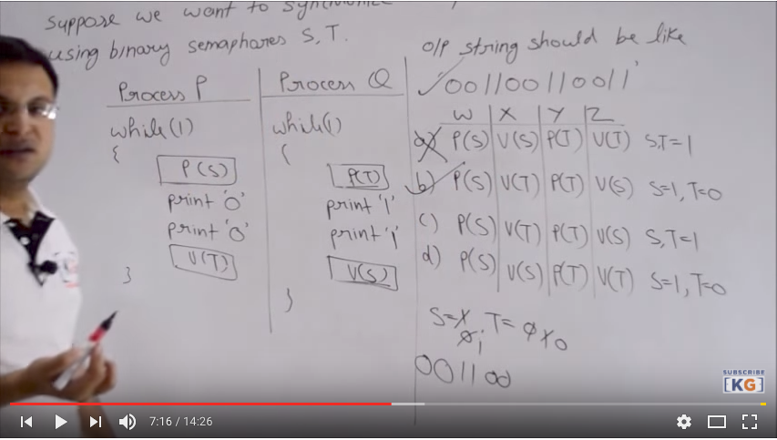

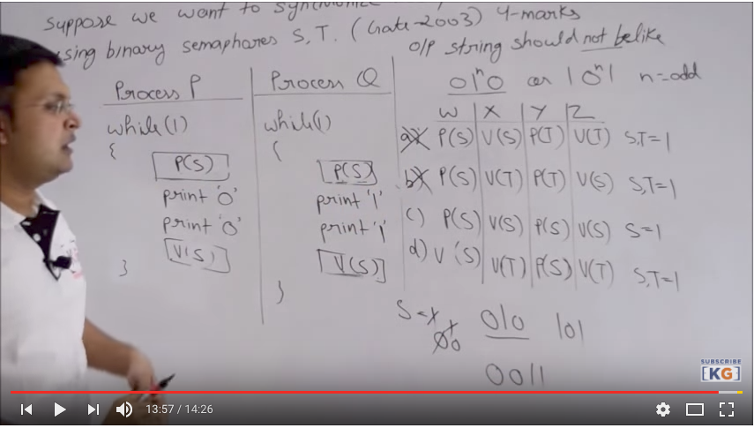

Video 12 : Previous Year Gate Questions | Semaphores

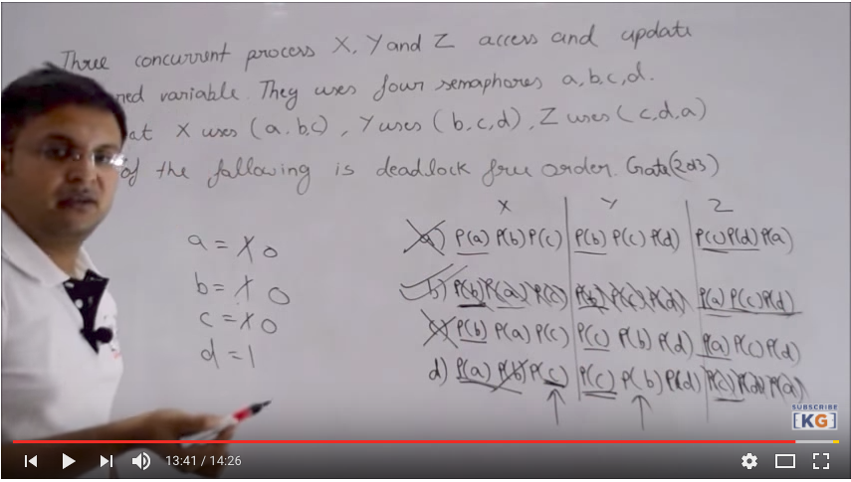

Video 13 : Producer Consumer Problem | Semaphores

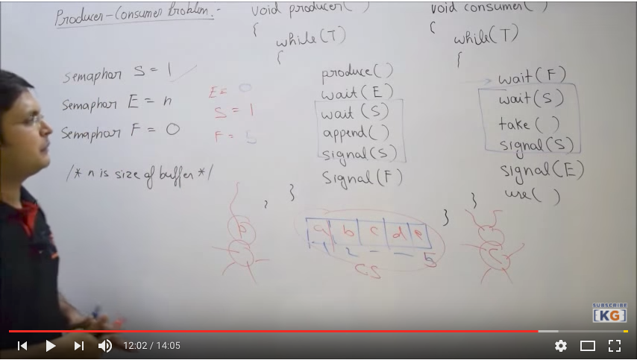

Video 14 : Reader Writer Problem | Semaphores

